Modelling and simulation of a 4-dof forwarder loader

|  |  |
| --- | --- |
| Document status | Initial / Final Report |
| Date | 26.2.2017 |
| Authors | Pallab Ganguly, 267602  Toan Le Duc, 267945 |

Table of Contents

Modelling and simulation of a 4-dof forwarder loader 1

Figures 3

1 Introduction 4

2 General Description 5

2.1 System Features 5

2.2 Implementation plan 5

3 Modelling 7

3.1 Modelling hydraulics 7

3.2 Modelling of individual components: 8

3.2.1 ¾ DIRECTIONAL CONTROL VALVE 8

3.2.2 ACTUATOR MODELLING(CYLINDER) 11

3.3 The aim in modelling 12

3.3.1 Friction Model 12

3.4 Modelling mechanics 15

3.5 Modelling of individual component (main parts) 16

3.5.1 Cylinder 16

3.5.2 The Extrusion 1 and 2 18

3.5.3 4 bar linkage 20

4 Implementation and Testing 22

4.1 Off-line implementation 22

4.2 Real-time implementation 23

4.3 Graphical User Interface 25

4.4 Demonstration 26

5 Future development 27

Appendix 1. Self-evaluation 28

Appendix 2. Feedback 29

# Figures

Figure 3‑1 Hydraulic circuit 7

Figure 3‑2.2 Valve dynamics 8

Figure 3‑3 Relative opening 9

Figure 3‑4 Valve flow 10

Figure 3‑5 Overview of hydraulic part 11

Figure 3‑6. Friction model 12

Figure 3‑7 End collision model 14

Figure 3‑8 Overview of manipulator 15

Figure 3‑9 Rotator (Cylinder 1) and Cylinder type (2, 3, 4) 16

Figure 3‑10 General Simulink Multi-body model of Cylinder type 16

Figure 3‑11 Simulink Multi-body model of Rotator 17

Figure 3‑12 Extrusion 1 18

Figure 3‑13 Simulink model of Extrusions 19

Figure 3‑14 From left to right: X1 model and X2 model 19

Figure 3‑15 Extrusions designing code 19

Figure 3‑16 4 bar-linkage Simulink model 20

Figure 3‑17 4 bar-linkage parametters 21

Figure 4‑1 Sine wave signal input 22

Figure 4‑2 Results of Cylinders Displacements in offline simulation 23

Figure 4‑3 Real time simulation diagram 23

Figure 4‑4 Joystick model 24

Figure 4‑5 Graphic User Interface 25

# Introduction

First of all, thank for Intelligence Hydraulic Department, the exercise is designed to give student a lively view about how a hydraulic system work. The aim of this exercise is to build a simulation model of a 4 - actuator degree-of-freedom (DOF) hydraulic loader and to simulate it in real-time computer. This simulation model shall take into account the dynamics of the multi-body mechanical system as well as the dynamics (fluid compressibility, pressure generation) of the oil hydraulic system powering the loader. The loader will be driven in man-in-the-loop by commanding the spool position of the proportional valves in each of the four actuators. In time students practice with this exercise, they can improve their knowledge about system problems which could be happened in real life. Thus, we had faced with some issues cause by real time simulation which does not happen if we simulated in non-real time environment. The product is finally work with control signal from joysticks and give us how the hydraulic parts such as valve, cylinder, hoses make effect to the physic model and how important a good model is when one cylinder modelled with error in length cause whole system crash. In the other hand, based on hydraulic parameters we used, some motion does not look real and we need to modify them to make the model better.

In processing, the modelling section was smoothly modelled from the beginning with Simulink blocks but then problems occurred when we ran the simulation part. Due to one wrong direction frame, which we found out at the very last, we had to test the model many times but it gave wrong figures then we asked for help from course assistance. Besides, we did not connect the valves with the hoses, instead, the valves were connected directly to the cylinders in Simulink model of Hydraulic part. That cause the cylinders were simulated with some weird motion and gave wrong result to the Manipulator part. After that, we put the hoses Simulink models and changed friction force model from Seal friction to Hyperbolic Tangent friction, modified the nominal flow rate of valves and with new modified objects, the system can be opened and simulated in real-time environment.

Finally, this report is divided into four main parts as they are General Description, Modelling, Implementation and Testing and Future Development. Besides, we give our self – evaluation and feedback about exercise work in Appendix. The sources of referent documents used in this report are provided in Reference part.

# General Description

## System Features

The 4-dof forward loader basically consists of two parts:

a) Hydraulic.

b) Manipulator/ Mechanism.

The control signal is given by the joystick connected with the PC through UDP. That means the model is simulated in real-time.

The Hydraulic parts takes control signals, cylinder velocity and position as inputs and generates a force as an output. The control signal is given as an input by the joystick connected through PC, the cylinder velocity and position are the outputs of the manipulator/mechanism which are connected to the hydraulics.

The Manipulator takes force as input coming from the hydraulics and gives out the cylinder position and velocity which is connected to the hydraulics part.

The forwarder loader has multiple applications which is widely used in various sectors:

a) To handle & transport heavy materials for construction operations

b) To pick & place heavy logs of wood

c) Sometimes it is used for digging and excavation also.

The movement of the actuators are done by the tilt and extension of the loader and the gripping of the load is done by the bucket which is fixed at the end of the extension. The rotation and movement is controlled by the hydraulics.

* Simulation environment (take pic of Simulink and simmechanics)
* Real-time environment (take pic of Realtime environment and joysticks)

## Implementation plan

The forward loader system is divided into three parts.

1. The real time simulation (which involves a control signals which is send to the hydraulics by the joystick and a receiver which **measures the angle of rotation** from the manipulator).
2. The hydraulic which consists of several subsystems:

a) ¾ directional control valve:(The valve consists of Valve dynamics, Relative openings and flow path).

b)Cylinder(End collision and friction model)

iii) Manipulator which consists of sereral subsystems:

1. Rotator

b) Pillar

1. Lift cylinder attached
2. 4barlinkage cylinder attached
3. Extension cylinder attached

In section 5, the system is described more about how it will be improved in future.

# Modelling

## Modelling hydraulics

The aim of Hydraulic circuit is to model different parts. The subsystem of hydraulic parts are given below:

* 4/3 directional control valve
* Hoses
* Cylinder
* End collision model
* Friction model

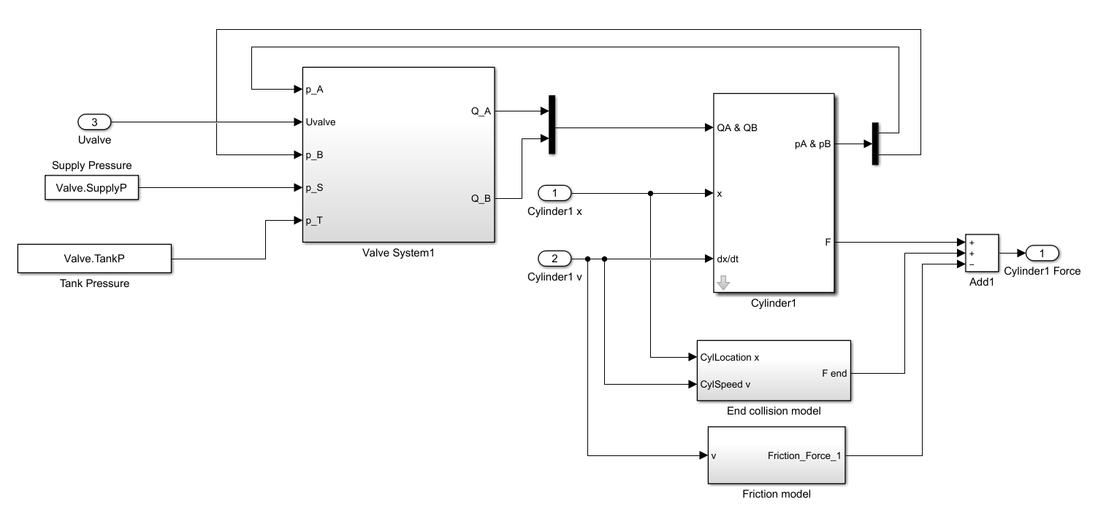

Figure 3‑1 Hydraulic circuit

The supply pressure and the input from the controller serves as an input to the modelled system. The 4/3 direction control valve signifies 4 ports namely P(supply), T(tank), A (chamber A of cylinder) and B (Cylinder chamber B) and 3 positions (-1,0,1). The hoses serve as a transport medium for the fluid from valve to cylinder chambers. The pressure of the fluid flow inside the hydraulic cylinder actuates the motion of the piston which generates a force for the mechanism to work.

The modelling is done in two steps:

* Modelling of individual components
* System verification

## Modelling of individual components:

### ¾ DIRECTIONAL CONTROL VALVE

* Valve modelling

The valve modelling consists of **Valve Dynamics, Relative opening and flow paths.** The possible combination of the valve PA-BT and PB-AT

The valve modelling consists of **Valve Dynamics, Relative opening and flow paths.** The possible combination of the valve PA-BT and PB-AT

* Valve Dynamics

The **valve dynamics** consists of a saturation, transport delay and a second order transfer function. Saturation in needed along with second order transfer function because of possible overshoot. Delay function is an important parameter for on/off valve as it can be different for opening and closing and depends on different pressure levels. It is modelled using data3 of valve data.

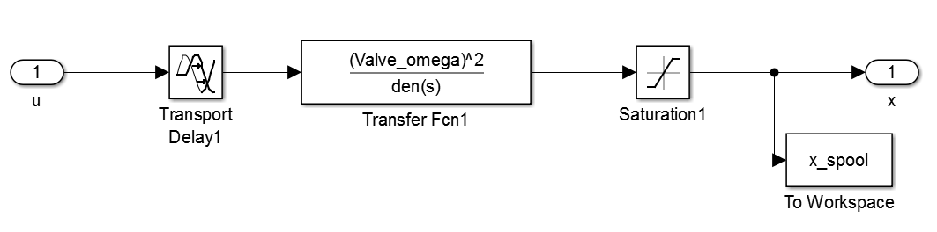

Figure 3‑2.2 Valve dynamics

* Relative opening

The **Relative opening** serves as a bridge between spool position and flow rate. Here it is modelled using look up tables. The data points for look up tables are obtained from graphs which are plotted as spool position vs volume flow rate for individual combination such as PA-PB-AT-BT from data 1 and 2 of valve data. It is observed from the possible combinations of PA and PB the graphs show a gradually increasing exponential curve hence the volume flow rate is divided by the maximum valve such as (QA/maxQA). On the other hand, BT and AT is divided by the minimum valve of the volume flow rate such as (BT/minBT) due to decreasing exponential curve. The reason of dividing with the maximum/minimum valve was to set the maximum limit to unity so that valve from the graphs can be computed easily. Leakage is considered because of hydraulic fluid is flowing in the pipes. The outputs are the relative openings of four different ports PA, TB, PB and TA, which are connected to the input ports of the orifice.

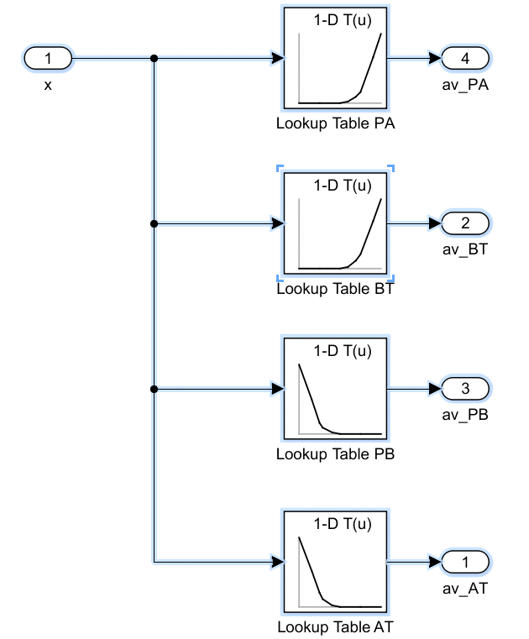

Figure 3‑3 Relative opening

* Flow path

The flow paths are modelled using 4 orifice block, such as PA, PB, AT and BT. Four inputs ports are connected with the output ports of the Relative opening along with the pressure from the supply, tank, pressure at point A and B. Four orifice blocks are connected inside the flow path. Orifice blocks are used to control the pressure generally used for reduction and measure the flow rate of the fluid flowing. By reducing the pressure, cavitation formation can be controlled. The orifice inputs consist of two pressure ports one coming from either tank or supply and the other on is the pressure of either of one port namely A/B. The third input port is the relative opening of the valve connected from the relative opening. Example when the pressure of port A is considered the relative opening of connection PA is taken into account. The orifice has two output ports which are the mainly the volume flow rate. Example when the relative opening of PA is considered the two output ports are the flow rate of port A and port P. The flow from the ports P and T are connected to output ports A and B such that fluid is flowing from port P or T to ports A or B, so the output ports from P and T are terminated and volume flow from port A and B are connected to the input ports of the bidirectional cylinder

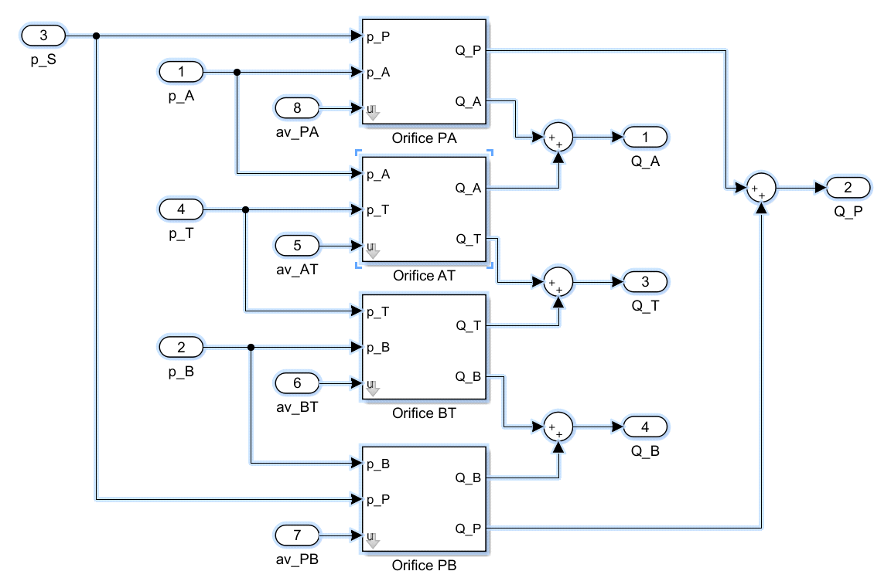

Figure 3‑4 Valve flow

### ACTUATOR MODELLING(CYLINDER)

The cylinder used in our model is bi-directional cylinder with chamber A and B, it is modelled using 2 volume blocks representing individual chambers respectively. The cylinder is modelled using the volume and its derivative equations. If there is an inflow to chamber A from valve through hose there will be outflow from chamber B to valve through hose. Since the cylinder by itself cannot generate position and speed , an initial force is given as an input to the mechanism by the cylinder as a result of which speed and position of the plunger of the cylinder can be computed. The cylinder consists of friction model and an End collision model which is modelled as follows. We used four cylinder subsystems, which gives the required speed and position for four cylinder designed in the Manipulator.

Figure 3‑5 Overview of hydraulic part

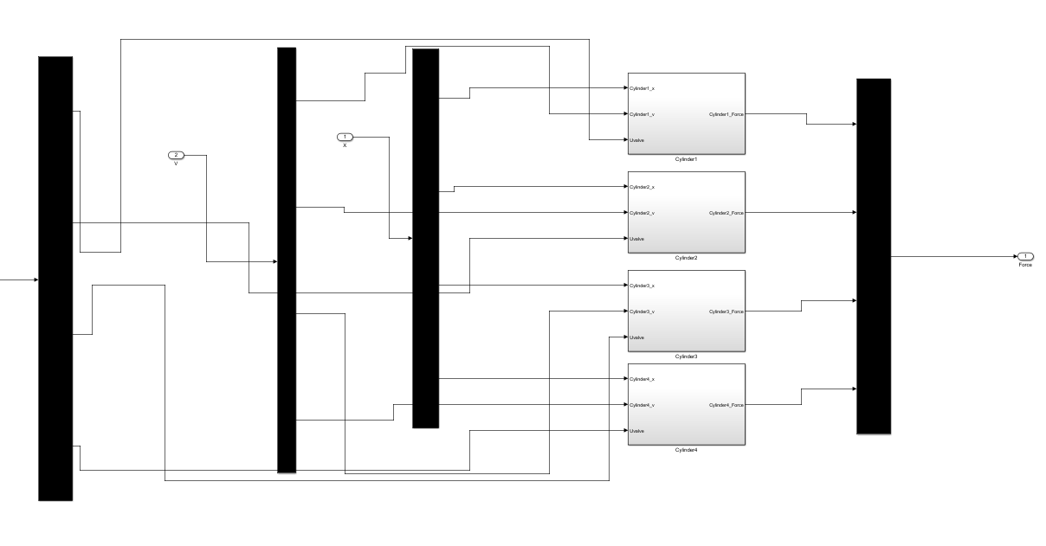

## The aim in modelling

### Friction Model

A subsystem of friction is considered where the input port velocity of the cylinder plunger and the output is the frictional force. Friction is considered inside the cylinder because completely smooth surface cannot exist and there is relative movement of the surface. Static friction Fs and coulomb friction Fc is considered where static friction is 5-10% of the maximum force exerted by the hydraulic cylinder and coulomb friction is 10-40% smaller than static friction. Normally the static frictional force holds the cylinder load.

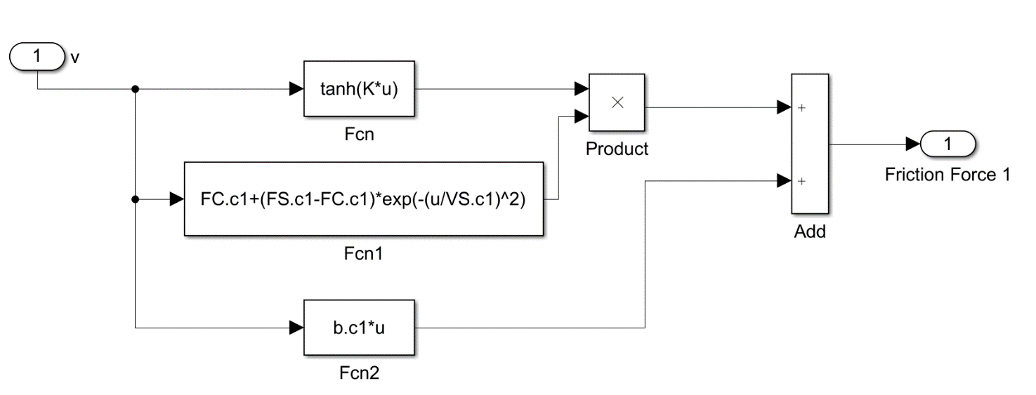

Figure 3‑6. Friction model

Hyperbolic tangent friction force is given below:

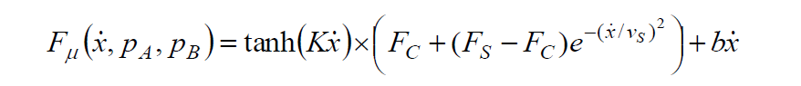

Where F­c is denoted as Coulombic Friction and Fc is Static friction.

In our model we did not use the dynamic friction model as the system was not running in real time simulation and the parameters we hard to tune.

We have considered as static friction as 10% of maximum force and coulomb friction as 40% of static friction. Viscous friction “b” in the equation is assumed to be almost equal but we have taken it little less the static friction.

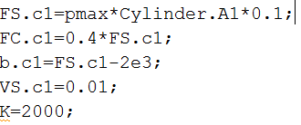

We had to tune the parameters to avoid damping and oscillations.

To avoid the cylinders that we used in the manipulator to exceed the maximum stroke length we used the end collision force. If we have not used the end collision model the piston from the cylinder moves away. Example in cylinder 4 where the piston is connected to the first extension if the end collision model was not used the piston along with the extension 1 and 2 move away. In order to keep them attached we designed the end collision model. The equation used are:

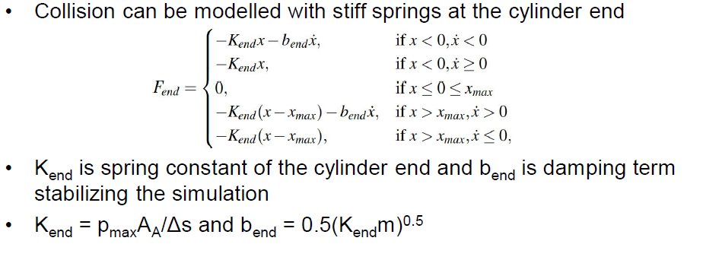

The Spring constant (Kend )and the Damping (bend) are the main factors of the end collision force which we keep different for different cylinders. These parameters where tuned to minimise oscillation and vibration between moving parts.

Eg for cylinder 2 the Kend and bend valves are:

C:\Users\palla\AppData\Local\Microsoft\Windows\INetCacheContent.Word\kend.png

The end collision subsystem model is:

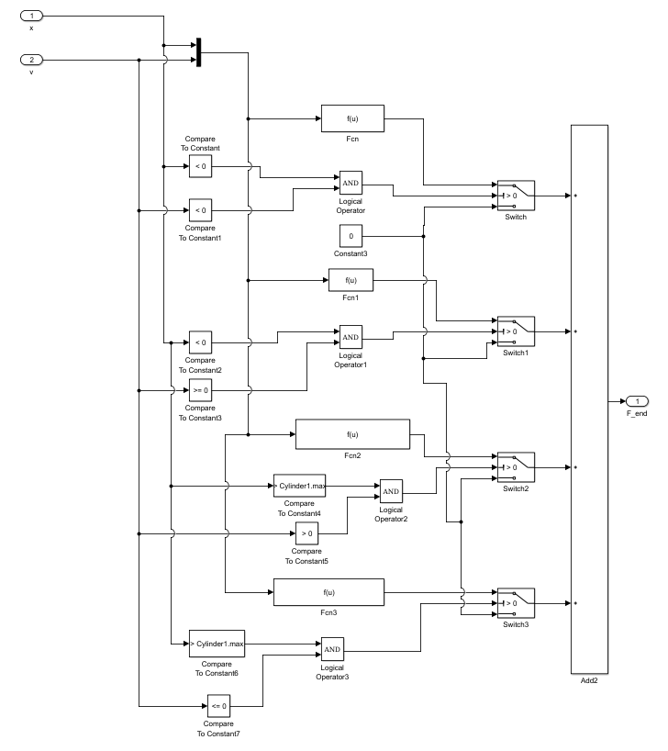

Figure 3‑7 End collision model

## Modelling mechanics

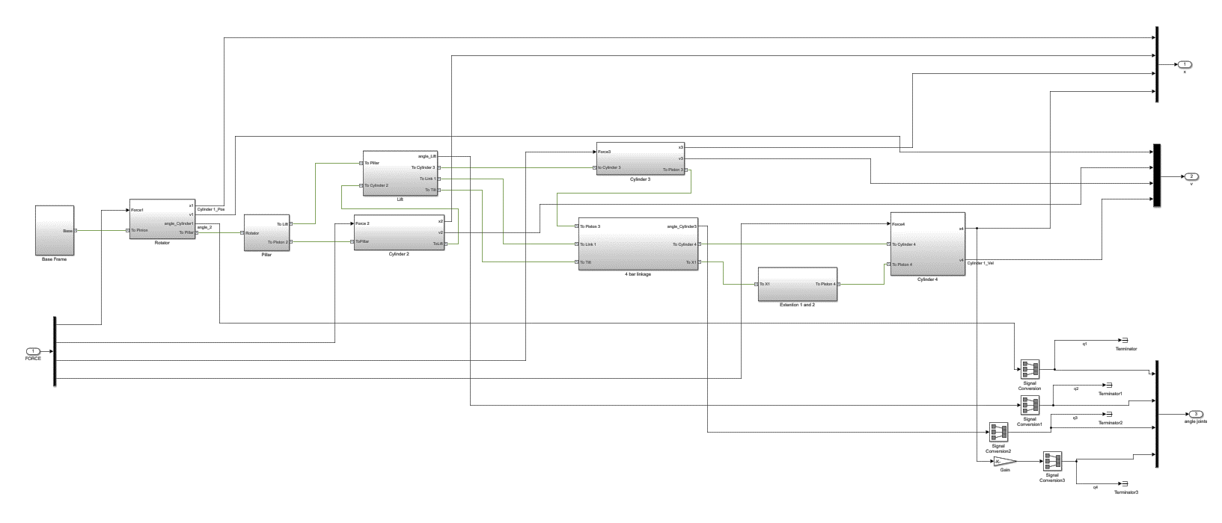

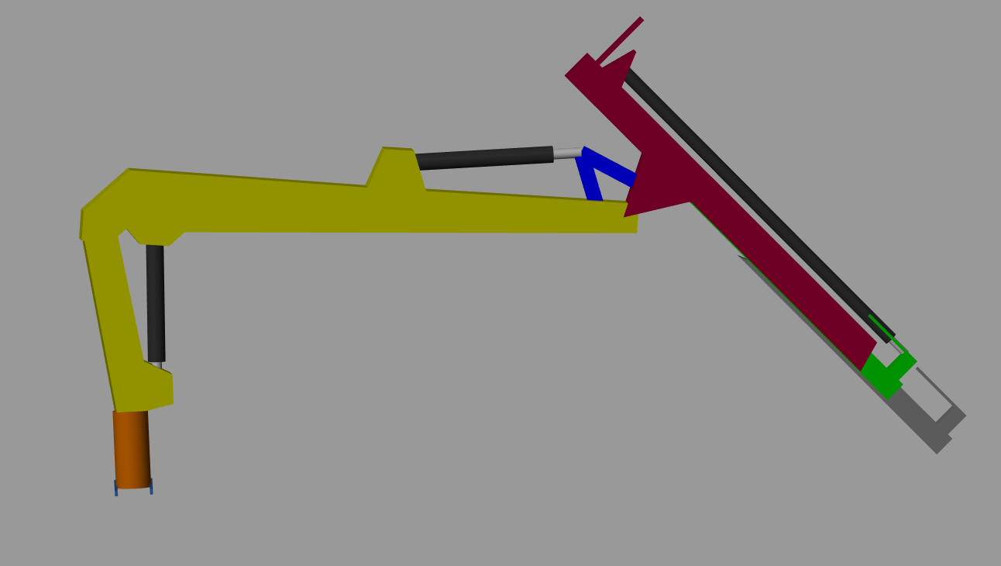

Figure 3‑8 Overview of manipulator

The mechanic part is modelled with following objects:

1. Base frame
2. Rotator (Cylinder 1 x 2)
3. Pillar
4. Lift
5. 4 bar linkage
6. Extension 1 and 2
7. Cylinder (2, 3, 4)

Each object is described below.

## Modelling of individual component (main parts)

### Cylinder

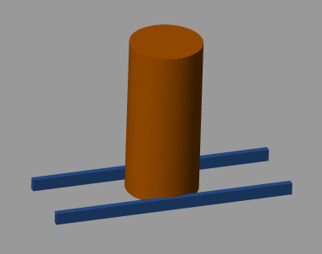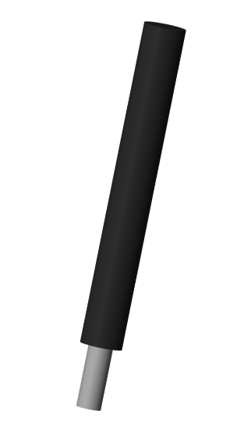

Figure 3‑9 Rotator (Cylinder 1) and Cylinder type (2, 3, 4)

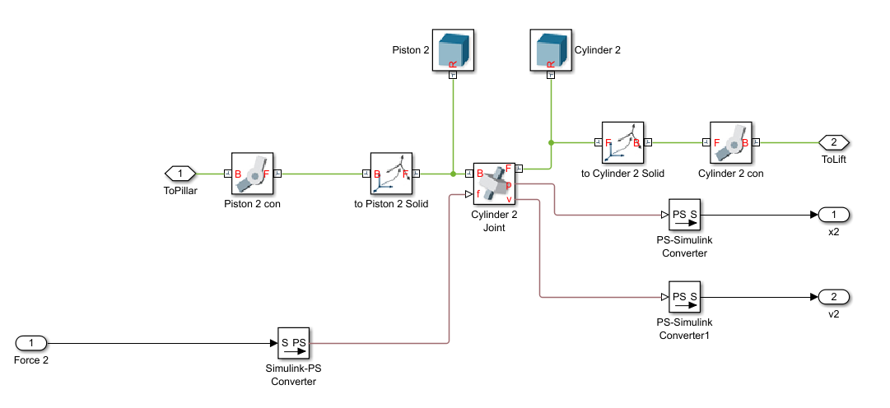

Figure 3‑10 General Simulink Multi-body model of Cylinder type

Cylinder stroke is calculated by sensing the movement attached between cylinder and piston

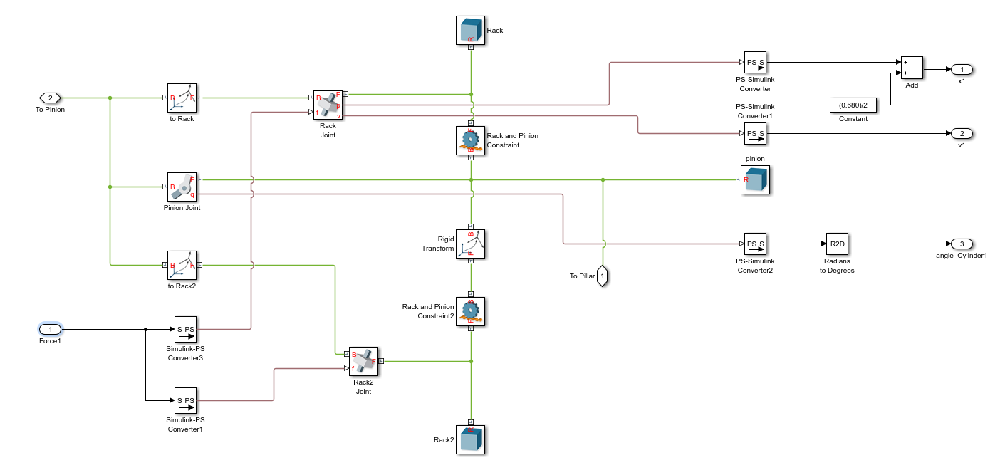

Figure 3‑11 Simulink Multi-body model of Rotator

In general, the cylinder was created with some base parameters which show in table below

Table 1 Cylinder Parameters

|  |  |  |  |
| --- | --- | --- | --- |
| **Parameters** | **Cylinder 2** | **Cylinder 3** | **Cylinder 4** |
| **Radius** | 0.06 | 0.0575 | 0.045 |
| **Length** | 0.92 | 1.068 | 2.64 |
| **Mass** | 72*2/3 | 65*2/3 | 50*2/3 |
| **Center of mass** | [0, 0, Cylinder.l2/2] | [0, 0, Cylinder.l3/2] | [0, 0, Cylinder.l4/2] |
| **Joint of cylinder** | [0.401, 0.016, 0] | [2.028, 0.550, 0 | [-0.737, 0.708, 0] |

Table 2 Piston parameters

|  |  |  |  |
| --- | --- | --- | --- |
| **Parameters** | **Piston 2** | **Piston 3** | **Piston 4** |
| **Radius** | 0.035 | 0.035 | 0.025 |
| **Length** | 0.61 | 1.068 | 2.64 |
| **Mass** | 72*1/3 | 65*1/3 | 50*1/3 |
| **Center of mass** | [0, 0, Piston.l2/2] | [0, 0, Piston.l3/2] | [0, 0, Piston.l4/2] |
| **Joint of cylinder** | [0.19, 0.14, 0] | [2.028, 0.550, 0 | [0.055, 0.235, 0] |

The rotator is combination of 2 cylinder 1, it has same function as other cylinders but different shape in model. The aim of each cylinder is create actuation for each big arm of the manipulator (Pillar, Lift, Tilt and Extrusions).

For more information about model, our model is attached with this report.

### The Extrusion 1 and 2

The extrusions are described base on same cross-section but with different size. The overview of Extrusions is illustrated below with main characteristics of them.

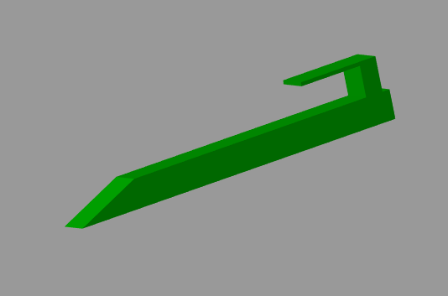

Figure 3‑12 Extrusion 1

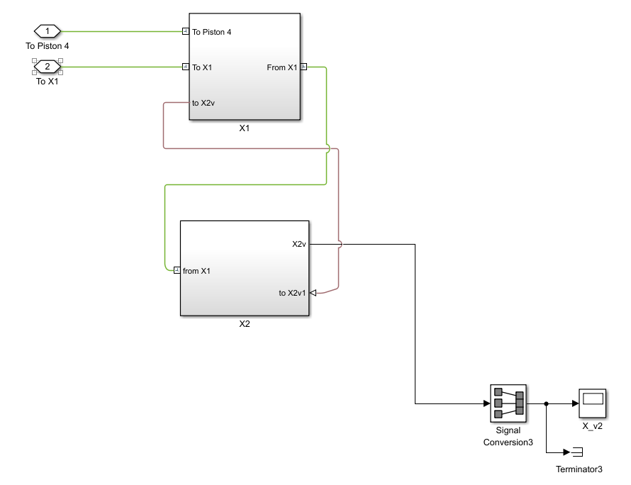

Figure 3‑13 Simulink model of Extrusions

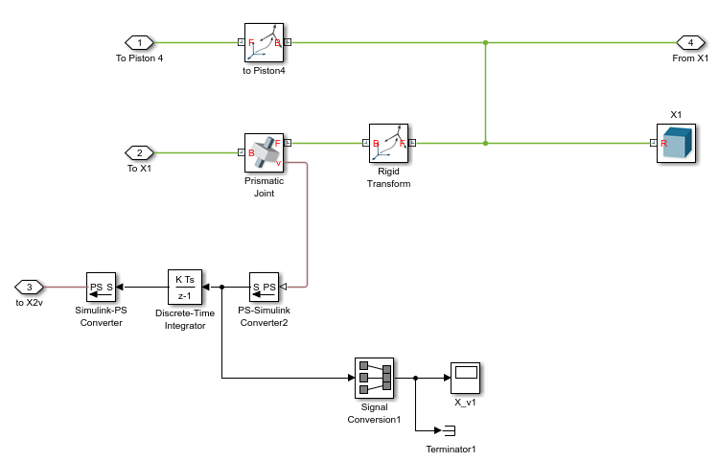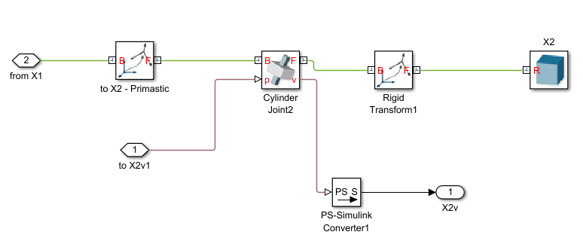

Figure 3‑14 From left to right: X1 model and X2 model

The Extensions are created from the code below as parameters to put into Solid block of Simulink.

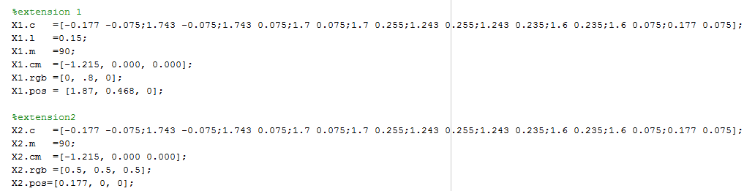

Figure 3‑15 Extrusions designing code

Notice in Simulink model of Extrusions, there is a sensing signal which takes results of velocity from Extrusion 1 (X1 in Figure 3-13) to calculate then put that signal as actuator signal of Extrusion 2 (X2 in Figure 3-13). The signal is converted from velocity to position signal, the purpose of this is making the Extrusion 2 to move as same velocity as Extrusion 1.

### 4 bar linkage

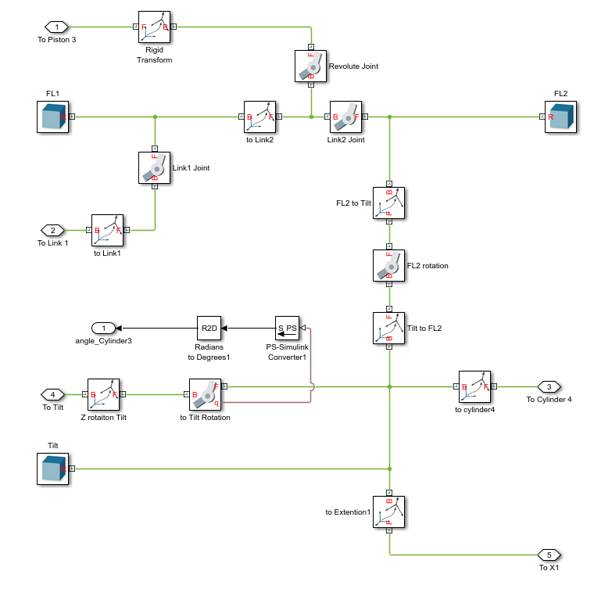

Figure 3‑16 4 bar-linkage Simulink model

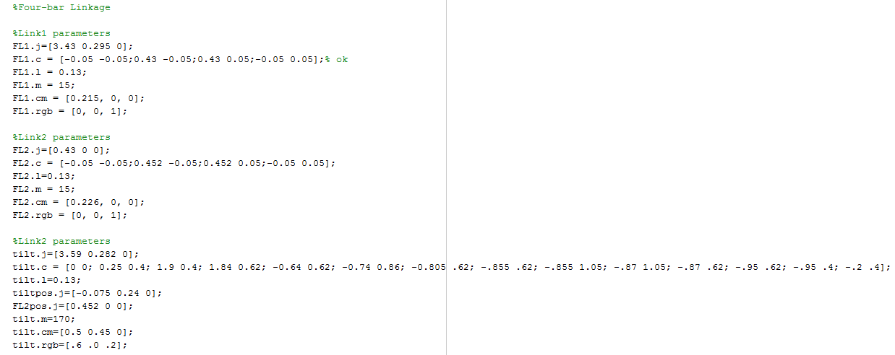

Figure 3‑17 4 bar-linkage parametters

This part of manipulator was designed based on lecture slides and we made some reference from Matlab SimMechanics Examples.

# Implementation and Testing

While building the manipulator the most challenges we faced was with the “Rigid Transform block” . The rigid transform block is responsible for the translation and rotation of parts. The movement of the parts is only possible along z-axis fixing bugs and making each part move was challenging. We had already designed the pillar , lift and cylinder 2 along with the rack and pinion which we used in our model. We started our model by using the pillar. Cylinder 2 which is attached with pillar and lift after that we used the same cylinder but changed the dimension of piston and cylinder and attached with the lift and four bar linkage. So we modelled the four bar linkage and attached the cylinder 3 and tested . After that the tilt is attached with the lift and the four bar linkage followed by the extension 1. The cylinder 4 is attached with the tilt and extension 1 . Then we again tested the model and its movement. We had some initial problems in implementing it and then we attached the extension2. At the end we attached the rotator part and then we tested the manipulator. Now we had to attached hydraulics part with our manipulator . And tested the model giving a initial sign wave signal. I

In the Hydraulics parts we first modelled the friction and the end collision model attached it with the cylinder. For testing that the hydraulic and manipulator worked properly we commented out 3 cylinder model from the hydraulics parts so now only one hydraulic is given an output force to the actuator and correspondingly we made the movement zero of 3 cylinders in the manipulator such that one cylinder is a able to actuate only the corresponding cylinder in the manipulator. We tested it for all the four cylinder and finally implemented our model.

## Off-line implementation

The off-line simulation was smoothly happened when the whole model work exactly follow moving of joystick. In this section, the model show the vibrations when each cylinder get to the edge of them. These vibrations was modified after that by re-calculating friction force and end collision force of hydraulic cylinder model. The results of cylinder displacements is shown below.

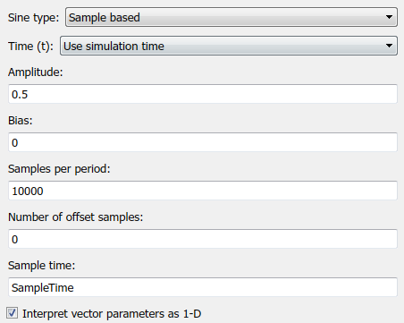

Figure 4‑1 Sine wave signal input

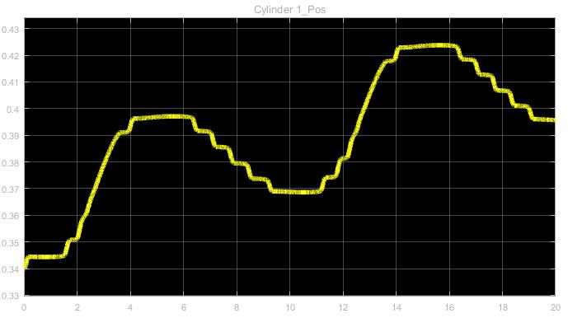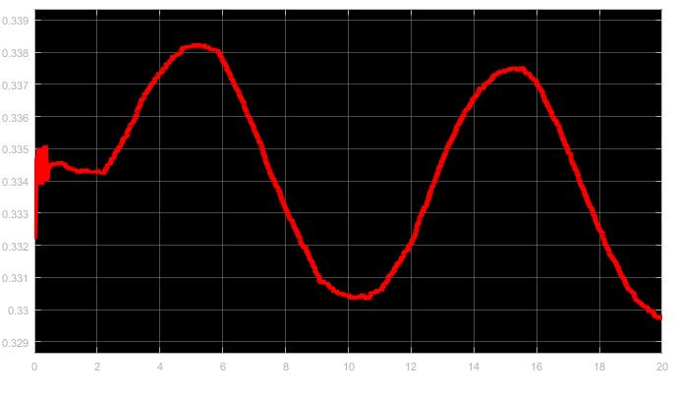

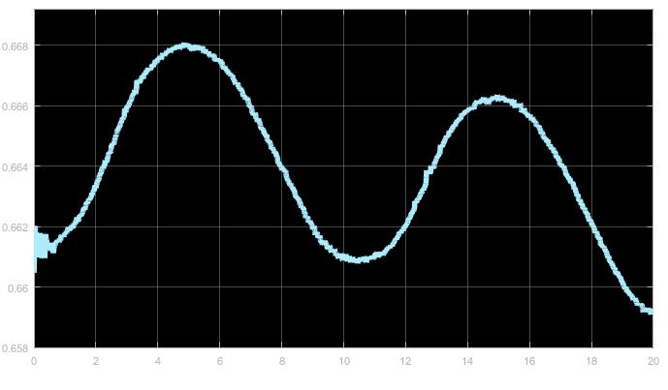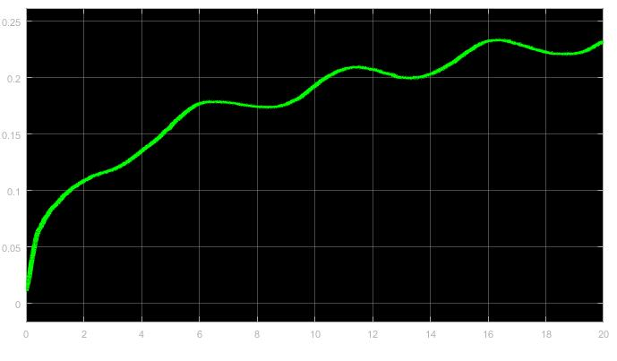

Figure 4‑2 Results of Cylinders Displacements in offline simulation

(From left to right and top to bottom: X1, X2, X3, X4)

## Real-time implementation

First of all, we modified the environment in Simulink model, then it can run in real-time. We set up the system based on instruction from lecture slides. But after that, the model did not run then we check again parameters given into system. Finally, we can make the system run in real-time simulation environment.

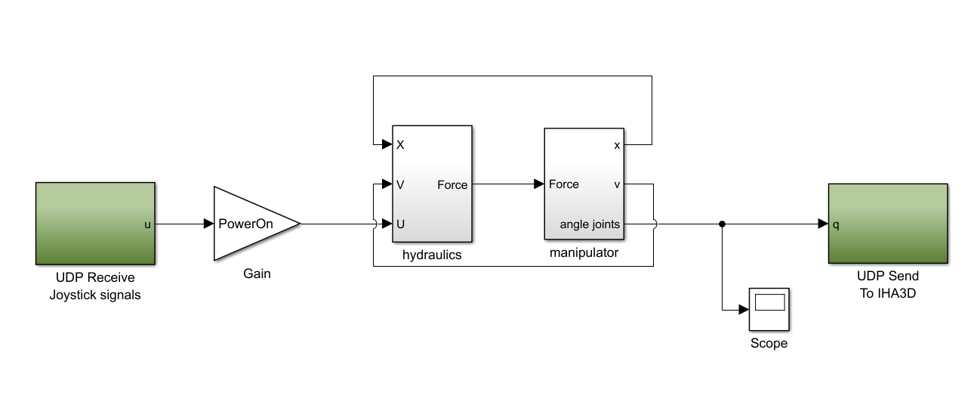

Figure 4‑3 Real time simulation diagram

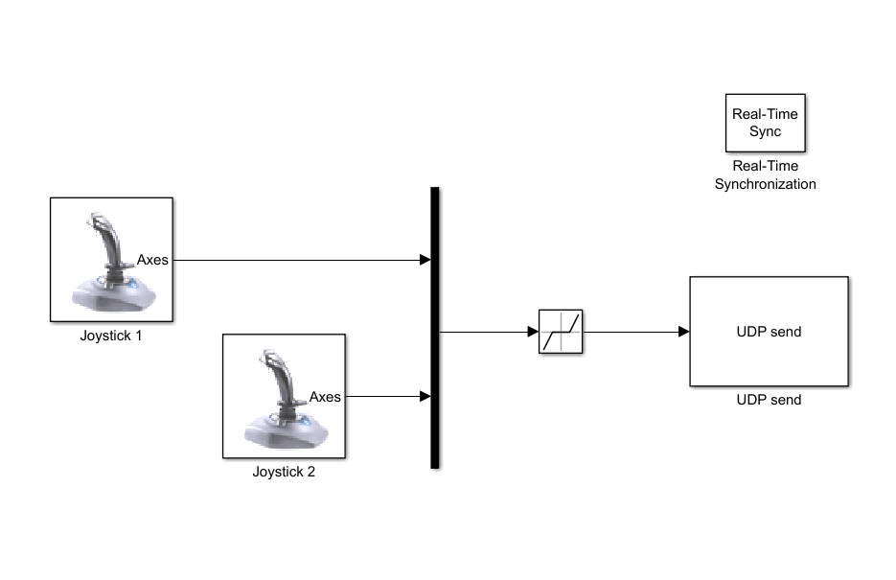

Figure 4‑4 Joystick model

After successfully testing the model in offline simulation we connected the input and output ports with joystick signals and IHA3D respectively. We modified the ip address with our real time computers.

We initially had some issues with the solver configuration we changed our solver to ode5 and it gave good results.



The sample time was taken as 0.001.

While running our model in real time we noticed the speed of the rotator was more that the movement of the extension. The extension was moving very slowly we tried to tune our valve flow rates the ”Nominal flow” and we where quit successful in that but not fully succeeded.

## Graphical User Interface

GUI is create with 4 digital clock to show the angles of 3 joints alternately. They are the angles of cylinder1(Rotator), Lift, Tilt and the distance between extension 2 movement.

The second row have 2 pan meter which shows the velocities of extension 1 and extension2 with which we can observe that if the extension 1 and extension 2 is moving in same or different velocities.

The one left is the adjustment slide button which used to adjust the supply pressure (scale in bar unit).

The on-off switch has the purpose to turn on or off the system.

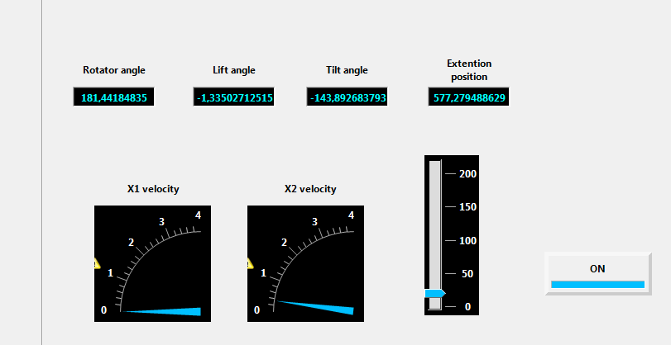

Figure 4‑5 Graphic User Interface

## Demonstration

The model that we made has some major issues. First we would like to say that to control the damping and oscillation of the moving parts in the manipulator we tuned the collision force and friction parameters along with the nominal flow of the valve. For example cylinder 3:

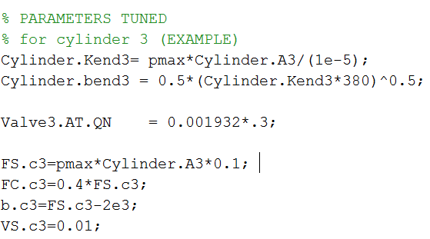

But in demonstration we faced some major issues like there was no oscillations while the pillar or the tilt was moving and secondly the extension was moving down slowly by itself when there was no input given by the joystick. The issues can be solved by further tuning the parameters in a border aspect like tuning the Bulk modulus , dead volume etc along with the parameters already tuned.

# Future development

* We can modify our model from the faults that occurred in real time simulation by tuning our parameters.
* We can think of a more environment friendly machine with less emission .
* We can modify our model in a more compact way so that we can make it more automated while increasing its efficiency of work
* The most important aspects we have to think about is its fuel efficiency.

This is how we can make a better machine in near future.

Appendix 1. Self-evaluation

The co-ordination between us was pretty good. We used to work separately in the initial phase. Then we used to work together.

* PALLAB: I was responsible for building the initial pillar lift and cylinder 2 which we did in exercise classes. The construction of tilt, extension1 and extension 2 was done my me. Then in later phase I constructed the end collision model and the friction model. And the tuning of parameters and make it run in real time was done my me. And the last part was the report . I wrote the following parts:

1. General Description
2. Modelling of Hydraulics
3. Implementation & testing(Description and Real time simulation)
4. Demonstration
5. Future Development

* TOAN: I was responsible of assembling the manipulator so that they had a working movement. I constructed the four bar linkage, rotation concludes racks and pinion and adjust the manipulator model then it could send feedback to hydraulic. I must say the task was very challenging for me and I learned a lot from it. I made the model work under offline simulation then after connected with the hydraulic part which I modified at last course and Pallab tuned the parameters I made real time running and the GUI and we tested it in real time. I wrote the following part:

1. Introduction
2. Modelling(Mechanics)
3. Implementation & Testing(Offline Simulation and Real time simulation)
4. GUI
5. Future Development

The group was very successful and we would like to work with each other in other projects also.

Honestly speaking the project was very challenging for us. So we give 4.

We started working on it from the end of December . So it took almost 2 months.

Appendix 2. Feedback

We learned a lot in this course . Special thanks to our professor Jouni Mattila and it would be very generous to only thank our assistants specially Toumo Kivelä who guided us in every problem we faced . I must say without his guidance it was not possible to complete our project. Thank you Sir for all the support an motivation you gave us.